This Work instruction consist of following activities.
- Dismantling & Erection of Blow Pipe & Accessories.
- Maintenance of Mud Gun.
- Maintenance of Tap Hole Drill Machine
- Drill Bit Fabrication.
- Drill Bit changing during cast opening.
- Blow Pipe Peep hole flange Opening & Closing
- Maintenance of Pneumatic Sample Conveyor
- Cast House 5t Hoist maintenance
- Clamping of Cooling plates
- Cooling plate testing for water leakage.
- Blanking of gas line flanges for isolation.
- Back flushing of cooling plates.
- Pug Mill maintenance
- Removal of struck drill bit from drill machine.
- Main launder & runner repair.

ACTIVIT-01: DISMANTLING AND ERECTION OF BLOWPIPE & ACCESSORIES

- Objective : - Safe dismantling and erection of blow pipe, tuyere, tuyere cooler and holder
- Scope : - Blast Furnace & Accessories
- Ref. : - MEC
- Responsibility : - Engineer In charge and workmen on job

PPE –s to be used :

Helmet, Safety shoes safety goggles and Hand gloves.

Aspect – impact

Oil Spillage | Land contamination & Resource Depletion
Oil traced waste generation | Land contamination & Resource Depletion
Scrap Generation | Resource Depletion
Asbestos | Hazardous waste
Dust Generation | Air Pollution

Procedure:

- Take work permit from production department and check that tuyeres are plugged and wind is OFF.
- Ensure that all-necessary tools and tackles are ready. Use tested chain block/D shackles/slings of minimum capacity of 3 T.
- Blow Pipe shifting to be done by manpower over tuyere platform for replacing Blow Pipe-02 to 07.
- Move the blowpipe with manpower and position close to front nozzle
- Ensure Blow Pipe is kept in front of Blow Pipe to be removed.
- Remove 2nos tie rods and 1 no turnbuckle.
- Take out the 3 wedges of horizontal joint.
- Remove the bolts and take load on 3t chain pulley.
- Slowly lower the blow pipe by chain pulley.
- Pull back and lower the blow pipe on the ground.
- Ensure proper Gasket groove cleaning of Horizontal Blow pipe flange.
- Replace the Ceramic Copper Gasket with new one and provide 25mm fiber blanket inside copper gasket.
- To lift the blowpipe, near tuyere stock and lift with the help of 3t chain pulley.
- Push the blow Pipe and position to the center of tuyere seating.
- Fix 2 nos tie rods and 3 bolts of horizontal joint.
- Check the Gap after tightening of all 3nos M30 X 120 HT bolts, gap should be around 5mm all around the horizontal flange.
- Check gap between tuyere seating and blowpipe with 0.05mm feeler gauge to ensure 100% seating.
- Procedure for removing blowpipe No. 1 & 8

- Drill Mc & Mud Gun Power pack electrical isolation should be taken).
- Ensure that metal runner is cleaned by production department and covered with MS / aluminum gratings by maintenance department before starting the job.
- Place 2 nos bricks on tuyere cooler holder bottom to prevent SS pipes damage.
- Use certified chain block of 3T capacity in place of trolley for removing blowpipe
- Physically inspect the suspension point of chain block for its structural stability to hold the required weight of blowpipe.
- Position the chain block at the appropriate position, the suspension point is provided for hanging the chain block. Follow work procedure WI/MAINT/12 for material handling. G. After slinging the blowpipe, hold the blowpipe with minimum tension.
- H. Loosen the tie rods. If it cannot be loosened, use “RUSTLIC”. If the tie rod is not coming out, gas cut spring with due care to avoid recoil of the spring. Alert the workmen / visitor before cutting the spring loaded hook
- Remove 2nos tie rods and 1 no turnbuckle of blowpipe. I. Take out the 3 wedges of horizontal joint.
- Remove the bolts and take load on chain block.
- Pull back and lower the blowpipe ensuring that SS pipes of tuyere & tuyere cooler are not damaged.
- Replace the copper gasket with new one and provide 25mm fiber blanket inside copper gasket.
- Fix back the blowpipe with chain block, ensuring that it is positioned at the center of tuyere seating.
- Follow steps No 16 & 17.

- Procedure for Tuyere/Tuyere cooler changing

- This activity comes after removing the blowpipe.
- Replace SS pipes of inlet (1”) and outlet (3/4”) and SS braided water hoses.
- These SS braided hose fitting will have female fitting with male adapter along with threaded part
- Replace tuyere cooler if required using the above procedure.
- Replace tuyere holder if required during relining.
- Maintain tuyere to tuyere cooler distance to 300 mm all around. Check the gap with 0.05mm feeler gauge if required.

- Fix the peep hole assembly with gasket to blow pipe.
- Ensure all tight fittings at the joints to avoid any leakages.
- Re weld the hooks attach to furnace where tie rods are hooked if required.
- Clear the work permit.
- For any cutting/ welding operation follow procedure SP 44 & WI/MAINT/94 24. Follow the house keeping procedure as per instruction stated in WI/MAINT/91.

DO:

- Check the condition of chain block and its certification label before taking in use.
- Check the chain block holding hook for any corrosion or wear out.

DO NOT:

- Stand below the hanging material while lifting the blowpipe.
- Gas cut the spring loaded tie rod.

ACTIVITY-02: MAINTENANCE OF MUDGUN

Objective : Safe maintenance of mud gun for optimum performance
Scope : Blast Furnace Accessories
Ref : WI/MAINT/93, SP44, WI/MAINT/12
Responsibility : Engineer In charge
PPE’s to be used: Helmet, Safety shoes, Cotton cloth, hand gloves and goggles, ear plug.
Work No 1 : Mud gun centering
Work No 2 : Replacement of mud gun barrel assembly
Work No 3 : Replacement of mud gun assembly
Work No 4 : Replacement / Opening of mud gun nozzle
Work No 5 : Mud gun barrel making
Work No 6 : Replacement of hoses
Work No 7 : Turning shaft replacement /Bush replacement
Work No. 8 : Hydro motor Changing
Work No. 9 : Vertical adjustment wire rope changing.
Work no 10 : Mud barrel Assembling

1. Take electrical shutdown of all pumps and obtain work permit from production department.
2. Lubricate all gears and bushes as per lubrication procedure WI/MAINT/93.
3. Check turnbuckle and wire rope and replace if required.
4. Check all hoses, fittings, and hydro motor for leakage.

Work No: 1 : Mud gun centering
- Take the permission from cast house engineer to work on centering of mudgun. Loosen the turnbuckle lock nut.
- Adjust the turnbuckle bottle with 25nb pipe approx, 1 meter long & 20mm dia rod which is welded on the turnbuckle bottle & adjust to the center of the tap hole. Use 55mm ?DE? spanner for loosening & tightening lock nut.
- After getting clearance from cast house engineer, lock the lock nut with 55 mm DE spanner.
- In case, a fitter wants to use pipe wrench, he must take adequate care to avoid slippage while tightening/loosening the turnbuckle.

Work No 2: Replacement of mud gun barrel assembly including cylinder
- Take clearance from production.
- Empty the clay from the barrel by operating the injection cylinder & keep piston in backward position.
- Take shutdown of mud gun power pack.
- Remove both the injection hoses & loop both the cylinders ports with hose pipe.
- Install chain block of minimum 3T capacity & remove the bolts from the turning shaft flange and cut the locking flats welded on the flange.
- Lower the barrel slowly along with the turning shaft and shift to the sand platform with the help of 5T hoist.
- Install new barrel by lifting with one chain pulley block. 5T hoist can be used if the barrel can be positioned right below the hoist. (Follow procedure WI/MAINT/12). No oblique pulling is allowed.
8. Connect the hoses & take trial. Check all hoses for tightness.

Work No 3: Replacement of mud gun assembly
- Take clearance from production for working on mud gun assembly.
- Take electrical shutdown of power pack (All pumps).
- Remove all the hoses & loop. Tie Cotton cloth on the nipple of the hose to avoid dust particles going inside the hose. Tag all the hoses to avoid confusion during trials.
- Remove mud gun barrel assembly as per the above procedure.
- Loosen all foundation bolts after keeping load on 5T hoist.
- Slowly raise and shift the assembly with the help of another chain pulley block to side. Use 5T hoist / crane to take out from cast house. The mud gun should be supported using two 5 MT chain pulley block while erection and dismantling.
- Install new mud gun base frame with shaft assembly using 5T chain pulley blocks and position.
- Tighten the bolts with heavy-duty spanner / pipe wrench.
- Fix barrel assembly as per above procedure.
- Connect all hoses & take trial. Check all hoses for tightness.

Work No 4: Replacement / Opening of mud gun nozzle
- Take clearance from production department.
- Empty the clay from the barrel by operating the injection cylinder & keep piston in backward position. ? Resp. : Production
- Collect the mud gun key from Cast house engineer - Responsibility: Shift fitter on instruction of shift mechanical engineer
- Check the gap between barrel bracket & nozzle bracket before opening the nozzle bracket bolts. It should not be more than 2mm.
- Loosen all the bolts & open the nozzle with brackets in BF2
- Remove the wedges (2nos) at the from portion of the nozzle in BF 1 and remove the tip..
- Before fitting the nozzle back, thoroughly clean the seating area. Clean and fix it. Tighten all the bolts till gap reduces to 2mm. Check if the corner of the nozzle bracket first touches the barrel. If it touches, & gap does not reduce to 2mm, then straightness of barrel bracket & nozzle bracket has to be checked & replaced if required. If gap is not reducing to 2mm, same to be brought to the attention of shift engineer. The shift engineer will measure the dimensions of nozzle, barrel and bracket. (Barrel bracket bore should be 304 mm, nozzle outside diameter should be 300 mm & nozzle bracket bore should be 302mm).
- In BF2 fix back the nozzle tip and tighten the nozzle by fixing wedges.
- Replace bracket / nozzle / barrel which ever has deviation.
- Return the key to the cast house engineer.
- Give clearance to production after taking trial.
- No spillage should take place between flanges of barrel and nozzle while closing the cast.

Work No 5: Mud gun barrel making for BF2
- Fabricate the mud gun barrel as per drawing no. 12000351.
- Check the critical dimensions of barrel bracket i.e. 304 mm at the nozzle seating area.
- Fit all the inspection doors of the barrel.
- Barrel bracket bolt holes diameter should be 34mm.

Work No 6: Replacement of hoses
- For changing the hoses ensure that mud barrel assembly is located at extreme back position.
- Take out the mud gun key (translation and injection ) Responsibility: Shift fitter on instruction of shift mechanical engineer
- Slowly loosen the fittings to release the hydraulic oil pressure and collect the oil in empty container. Care should be taken to prevent the oil from falling on the ground. Use bucket to collect the oil from Hoses.
- Replace the damaged hose with new one. Replace the dowty/copper seal if require.
- Hoses are to be fitted without twisting and entanglement.
- Take the trial of the mud gun. Attend the leakages if any
- Give clearance to the production by clearing work permit.
- Ensure house keeping
- Shift old used grease & waste clay (used for trial) to respective scrap bin to return to store.
- Carry out housekeeping activity as per WI/MAINT/91
Work No 7: Turning shaft replacement /Bush replacement

- Take work permit from production.
- Take electrical shutdown of mud gun.
- Lower the mud barrel as per work instruction WI/MAINT/19.
- Disconnect the turnbuckle & remove the top axle of turning shaft.
- Fix a M20 eye bolt to the turning shaft & slightly keep it loaded using chain block of minimum 2 ton capacity in order to avoid lowering of the turning shaft .
- Now remove the top collar clamp & then slowly lower the turning shaft.
- Replace the bushes if needed.
- Using chain block, start lifting the turning shaft inside the reducing box.
- Once turning shaft is just inserted inside the reducing box, lift it using jack bolt (provision for jack bolt arrangement is available).
Note: Please ensure that lifting of turning shaft is done very slowly & cautiously, so as to ensure that main crown wheel shaft is not loaded.
- Once turning shaft is lifted , fix the top collar clamp & tighten the turning shaft bottom flange bolts also weld small plate to the flange at any 2/3 places
- Fix the mud barrel assembly as mention in Work No.2.
- Now re- fit the turning shaft axle & connect the turnbuckle.
- Clear the electrical shutdown & take trial.
- Clear the work permit & give clearance.

Work No. 8: Hydro motor Changing
- Take work permit from production.
- Take electrical s/d. of translation pump.
- Follow work instruction as per WI/MAINT/39. for handling hydraulic oil and removing hydro motor fittings
- Open the rear end gear cover, also open the small inspection door provided on top of reducing box assembly and disconnect the horizontal adjustment turnbuckle towards the main shaft end.
- Using a suitable hooking system with manila rope available with shift crew, insert the same in to the eye bolt provided on top of hydro motor.
- Slightly keep the manila rope loaded & start loosening of mounting bolts with the help of 24mm box spanner.
- Once all bolts are removed, slowly lower the hydro motor.
- Replace the hydro motor, slowly lift it using the same hooking system and fix all 5 bolts (M16x65HT bolts, with spring washers).
- Once all bolts are tightened re-inspect the meshing of pinion with intermediate gears.
- Re-connect all hydraulic fittings and clear pump s/d.
- Take swiveling trial &attend any leakage if noticed.
- Clear work permit and give clearance.

Work No. 9 Vertical adjustment wire rope changing.

- Take clearance from production.
- Ensure that mud gun is at rest position and in consultation with cast house engineer remove the drive keys of mud gun.
- Loosen the bulldog clamps & replace the old rope with new rope (length should be 1.5mtrs loop to loop).
- Ensure that 3 bull dog clamps are fitted on either side of rope and nuts are tightened fully.
- Take trial of mud gun and adjust the mud gun vertically & horizontally with respect to tap hole as needed.

Work No 10: Mud barrel Assembling

- Take trials of overhauled/new hydraulic injection cylinders and check for internal leakage
- Ensure that after trials that both ports of cylinders are plugged to prevent dust entry
- Assemble overhauled/new hydraulic cylinder to the intermediate barrel
- Connect plunger shaft along with retainer plate to the cylinder rod end. Ensure that while fixing plunger shaft, thread locker has been applied over cylinder rod end threading
- Tighten the plunger shaft
- Ensure that Teflon ring was put between plunger shaft and retainer plate
- Connect piston to plunger shaft and tighten with lock nut & dome nut
- Assemble front mud barrel to the intermediate barrel
- Fix the nozzle along with bracket

DOs:
- Wear gloves, goggles while working at cast house area.
- Take necessary precautions while working in cast house as it is a hot metal handling area.
- Take necessary care while handling items, which are smeared with grease and oil.
- Ensure nobody is within the swing area of mud gun while taking trial.
- Collect oil in tray of the hose pipes.
- Use proper slings while dismantling.

Don'ts :
- Wear gum boots while working in cast house.
- Take trial of the machine yourself. Only cast house operators and engineers are authorized to operate the mud gun.
- Do not take trial keeping hose pipes loose.

ACTIVITY-03: MAINTENANCE OF TAP HOLE DRILL MACHINE.

➢ Objective | : - Safe maintenance of Tap hole drill machine for optimum  Performance
➢ Scope | : - Blast Furnace Accessories
➢ Ref. | : - WI/MAINT/12
➢ Responsibility | : - Engineer In charge and workmen on job

PPE –s to be used :

Helmet, Safety shoes, Cotton cloth and complete sealed goggle

- Work No 1 : Drill machine drifter changing(BF1)
- Work No 2 : Replacement of hoses(BF1)
- Work No 3 : Replacement of swiveling cylinder
- Work No 4 : Replacement of carriage chain.
- Work No 5 : Replacement of Shank shaft

- Obtain work permit to work on tap hole drill machine from production department
- Lock the machine with chain, close the air valve and release the air pressure inside the pipeline.
- Remove the handle from the airline main valve.
- Display board “Work in progress” on main valve of airline.

Work No 1: Drill machine drifter changing

- Inform production cast house in charge & take work permit
- Take electrical shutdown.
- Remove the external cover.
- Remove all hose connection on the tap hole drill machine.
- Remove the drill machine assembly by removing mounting bolts.
- Fit the spare machine and tighten the mounting bolts.
- Connect all the hoses and ensure that the O rings are in good condition before tightening the hoses.
- Clear the shutdown and check for any hydraulic oil leakage.
- Fix back the cover and give clearance.

Work No 2: Replacement of hoses
- Inform production cast house in charge & take work permit.
- For changing the hoses ensure that mud gun assembly is located at extreme back position.
- Ensure that operator has switched off pumps and remove the keys from the operating cabin.
- Close swiveling line DC valve of Mud gun & Drill machine .
- Slowly loosen the fittings to release the hydraulic oil pressure and collect the oil in empty container. Care should be taken to prevent the oil from falling on the ground. Use bucket to collect the oil from Hoses.
- Replace the damaged hose with new one. Replace the dowty/copper seal if require.
- Hoses are to be fitted without twisting and entanglement.
- Ensure the hose with correct end fitting, as Chinese hose pipes are flat seat. I. Take the trial of the drill machine. Attend the leakages if any
- Give clearance to the production by clearing work permit.
- Ensure house keeping

Work No 3: Replacement of swiveling cylinder
- Take clearance from production cast house engineer.
- Swivel the machine and keep it perpendicular to main runner.
- Take shutdown of pumps.
- Disconnect the hose and collect the oil in bucket.
- Dismantle the old cylinder and fit spare cylinder.
- Connect the hoses and ensure to check O rings for any damage before tightening.
- Clear the electrical shutdown.
- Take swiveling trial of drilling machine, and check for any hydraulic leakage.
- Give clearance to production department.

Work No 4: Replacement of carriage chain.
- Take clearance from Production department.
  - Dismantle the hydraulic drifter as per Work no.1 and steps A to D
  - Close the swiveling line valves near the DC valve of mud gun & drill machine.
  - Identify the master link and disconnect the same.
  - Confirm if number of links of new chain is as per requirement.
  - Connect the new chain to one end of old chain.
  - Ensure the chain is of correct spec.as it is ANSI std.
  - Now slowly operate the carriage feed motor in such a manner that old chain shall get disengaged from the machine and new chain gets engaged on the machine.
  - Once entire chain is rolled on to the machine, disconnect the old chain from the new chain.
  - Now join the 2 ends of the new chain with master link and adjust the chain tension by adjusting the chain tensioner bolt.

Work No.5 : Replacement of Shank shaft .
  - Take clearance from production engineer by taking work permit.
  - Take shutdown of pumps.
  - Disconnect the flushing hose.
  - Now loosen the front 2 bolts as shown below

Remove both the bolts from here.

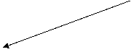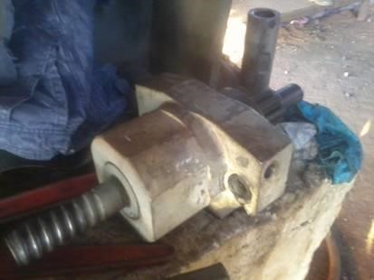

  - Now slide the entire assembly out as shown above.
  - Replace with the spare assembly & re tighten the bolts.
  - Ensure split pins are provided to lock nuts.
  - Connect the flushing hose back to its position.
  - Clear electrical shutdown.
  - Inform cast house operator to take trial of machine.
  - Clear work permit & hand over.

Dos

- Take necessary precaution while working in cast house as it is a hot metal handling area
- Take necessary care while handling items, which are applied with grease and oil.
- Ensure nobody is the swing area of drill machine while taking trial.
- Use chain block wherever applicable as per procedure WI/MAINT/12.
- Remove key of the drill machine before removing or fixing of drill bits in BF1 drill machine.

Don'ts

- Take trial of the machine by yourself. Only cast house operators and authorized engineers are authorized to operate machine
- Apply reverse force for loosening or tightening the lock nut / turnbuckle.
- Cross over Hot metal launder
- Do not stand in front of drill machine without collecting power pack operational key.
- Do not remove drill bits without collecting drill machine key from the operator or cast house engineer.

ACTIVITY-04 : DRILL BIT FABRICATION JOB

- Objective : - Safe fabrication of drill bit for optimum performance
- Scope : - Blast furnace Accessories
- Ref. : -
- Responsibility : - Shift Engineer & workmen on job

PPE –s to be used :

Helmet, Safety shoes, Cotton cloth, complete sealed goggle, welding screen, face shield & hand gloves.

Work No 1: Fabrication of Drill Bits

- Use safety goggles/face shield while cutting, grinding and chipping.
- Ensure that the drill bit pipe is being clamped while cutting.
- Drill bit length: a) BF#1 – 2400mm. & b) BF#2 2000mm
- Carry out the initial checks of the pipe cutting machine like
  - Ensure that the drill bit-cutting machine is guarded properly during working.
  - Wheels used are in good condition and has higher speed than the machine.
  - Ensure the wheels used are within the expiry date.
  - The maximum RPM mentioned on the wheel should be higher than what is mentioned on the machine • Ensure proper locking of lock nut.
  - Check the condition of V-belts.
  - Other visual checking and noticing any abnormal sound.
  - Ensure machine wheels are rotating in the direction marked.
- Cut the drill bit using drill bit cutting machine. Maximum allowable welding are 2 nos, - All joints should be inspected for good welding and straightness
- Incase drill bit cutting machine is under breakdown cutting set can be used for cutting the drill bit
- Check the shank for free movement with coupler
- Check the shank for the center hole is free of any restriction from inside.
- Ensure that min 6mm thick fillet welding is carried out for pipe .Follow welding procedure SP 44.
- Weld the drill bit with 6 mm fillet welding without any eccentricity 11. After welding the joint, check the straightness of the drill bit fabricated
- Stack the fabricated drill bits in the drill bit stand.
- Damaged pipe should be put in the scrap container and to be returned to store.
- Keep the work area neat and clean.
- Do not throw used pipes/bits on the floor.
- Follow housekeeping procedure as per instruction given in WI/MAINT/91.

Work No 2: Wheel changing

- Once the wheel is worn out to 180mm dia. (wheel reached near the label), wheel should be changed
- Switch OFF the MCB and remove ON/OFF key by putting in Off condition
- Tighten the shaft locking screw of the machine.
- Remove the lock nut, main nut and the washer on the shaft.
- Remove the used wheel and replace it with a new one.
- Fix back the washer, main nut and the lock nut and tighten it.
- Manually rotate the wheel to ensure its free movement and straightness.
- Loosen the shaft locking screw.
- Switch ON the MCB and insert ON/OFF key
- Check rotational direction of the wheel as marked (direction should be anticlockwise when person stand in front of the machine)
- Removed wheels should be returned to Stores.
- Keep the work area neat and clean
- Follow housekeeping procedure as per instruction given in WI/MAINT/91.

DO’s
- Use welders hand gloves during welding operations.
- Only trained workmen and certified welders should do the fabrication job.
- Only certified welding machine should be used.
- Care should be taken while moving the drill bits.
- Check direction of rotation of wheel
- The wheels used should be in good condition and has higher speed than the machine.
- The wheels used are within the expiry date.
- Return the used cutting wheels to Stores

DO NOT:
- Cut the drill bit pipes without holding it properly in the vice
- Retain used cutting wheels in drill bit shed

ACTIVITY-05: DRILL BIT CHANGING DURING CAST OPENING

- Objective : - Safe & Quality method for drill bit changing
- Scope : - Blast Furnace Accessories
- Ref. : -
- Responsibility : - Engineer In charge (mechanical & production), Production Foreman & Maintenance Fitter on job, production operator

PPE –s to be used :
Helmet, Safety shoes, hand gloves, ear plug and goggle

Procedure:

  - Drill m/c operating desk key has to be removed and kept by the maintenance fitter/production operator
  - Ensure that drill machine is at the extreme end and the airline valve is closed. ensure pump is kept off during first drill insertion into coupler
  - Ensure airline valve for flushing is kept closed and also air hose is locked with safety chain arrangement along with clamping.
  - Ensure modified coupler with plate isolating shaft and shank is used in drill machine.
  - old burnt drill bit is to be checked for hotness and to be removed by using hand gloves only. Ensure that drill bit is held in hand at the shank position only and place it on used drill bit stand.
  - Fit the new drill bit and ensure it is fixed properly into coupler and look for the looseness of scavenging assembly’s bolt nut also ensure that barricading chain is put in drill machine swinging area
  - Give clearance to production foreman by handing over the key.
  - Follow housekeeping procedure as per VL/IMS/PID1/MECH/WI/91.

Do:
  - Ensure drill machine is free from oil leakage
  - Only production engineer or tap hole operator should operate the drill machine. • Stay away from drill machine and runner while in operation

Do not:
  - Stand in drill machine swing area when it is in operation.
  - Move inside the swing area of drill machine during operation
  - Keep the burnt or removed drill bit below or by the side of drill machine

ACTIVITY-06: BLOWPIPE PEEPHOLE FLANGE OPENING AND CLOSING

Objective : - To open and close blowpipe peephole flange, assembly, safely
Scope : - Blast furnace accessories
Ref. : -
Responsibility : - Engineer In charge & the maintenance fitter on the job

PPE to be used :
Helmet, safety shoes, dust mask, hand gloves, goggle, apron, face shield

- Work No 1 : Peephole flange opening
- Work No 2 : Peephole flange closing
- Work No 3 : Peephole flange opening and closing for coke flushing
- Work No 4 : Peephole flange complete assembly opening & closing for gasket replacement or for assembly replacement
- Work No. 5 : Peephole flange opening & closing of blowpipe no. 1 & 8
Work No 1: Peephole flange opening (for blow pipe 2 to 7)
- Take clearance from Production Shift in charge for peephole flange opening.
- Person carrying out the activity should wear safety screen helmet, safety coat etc.
- Slightly loosen both the M20 nuts with a ring spanner and slide the flange by standing at the side.
- Open the peep hole assembly by standing at one side where flanges is fixed over the stud and not loosened side
- Care should be taken to see that the person opening the flange should not stand directly in front of the peep hole.
Work No 2: Peephole flange closing (for blow pipe 2 to 7)
- Take clearance from the furnace in charge after opening of tuyeres for peephole flange closing.
- Clean all the machined surfaces of the peephole assembly, with emery paper. If any unevenness is noticed, replace the flange.
- Push the flange downwards and tighten the bolt.

- Give clearance to production dept.
Work No 3: Peephole flange opening & closing for coke flushing
- This activity is to be done in the presence of the shift superintendent/cast house in-charge & the shift mechanical engineer.
- Wear an apron & face shield before opening the flanges.
- Ensure that the wind volume & pressure is reduced to the extent possible (from S.S).
- Slightly loosen both the M20 nuts with a ring spanner, and slide the flange by standing at the side.
- Care should be taken to see that the person opening the flange should not stand directly in front of the peep hole, to prevent hot coke impingement.
- Close the peephole flange after coke flushing
- Ensure no person stands in vicinity of peephole assembly during flushing.
- Person standing nearby should take adequate care for hot coke impingement.
Work No. 4 : Peephole flange complete assembly opening & closing for gasket replacement or for assembly replacement .
  - Take clearance from production cast house engineer
  - Ensure that the tuyere is plugged
  - Do wear a proper face shield
  - Remove all 3 wedges by hammering using a proper certified wooden hammer & keep it at a proper location ,
  - Now standing at one side (right hand side of blow pipe )OPEN the flange
  - Change the rope if needed, ensure that the rope is properly inserted into the groove to avoid leakage after closing.
  - Do not touch any interior parts of blow pipe while changing the rope as it will be very hot incase assembly has to be replaced then insert a crowbar or a rod of minimum dia. 20 mm through the peephole flange center hole and slightly raise it with the help of 2 persons .now remove the hinge pin and lower the assembly.
  - Again with the help of 2 persons insert the crow bar or rod into the center hole of peephole flange & lift the assembly and insert the hinge pin.
  - After taking clearance from production again standing at one side, close the flange. Insert the wedge matching the profile of the pin & hammer, till it gets fully tight. Ensure that the wedge area fully covers the inspection hatch
10. Give clearance to production

Work No.5 Peephole flange opening & closing of blowpipe no. 1 & 8
    - Take clearance from Production Shift in charge for peephole flange opening.
    - Ensure that Aluminum grating is placed on the runner after cleaning the runner jam
    - Person carrying out the activity should wear safety screen helmet, safety coat etc.
    - Remove the drive key of mud gun & ensure that drill machine main air line valve is kept CLOSED &.
    - For opening flange of blow pipe no.1, one can stand on mud gun firmly, and wearing a proper face shield, loosen both the M20 nuts with a ring spanner, and slide the flange by standing at the side .
    - For opening the flange of blowpipe no.8 one have to use a proper stool /platform and wearing a proper face shield, loosen both the M20 nuts with a ring spanner, and slide the flange by standing at the side.
    - Care should be taken to see that the person opening the flange should not stand directly in front of the peep hole
    - For closing flange, take production clearance Clean all the machined surfaces of the peephole assembly, with emery paper. If any unevenness is noticed, replace the flange
    - Push the flange downwards and tighten the bolt
    - Give clearance to production dept.

DO:

- Wear proper hand gloves that are meant for handling hot items.
- Check if runner jam is cleaned properly & Aluminum grating is kept over the runner while opening flanges of blow pipe no. 1 & 8
- Wear a proper face shield while opening the peephole complete assembly
- Wear proper face shield & Apron while carrying out coke flushing activity.
DO NOT :
- Stand in front of the inspection peep hole while opening.
- Stand in front of the peephole while opening the coffee pot valve.
- Carry out the flange opening job unless & until runner jam is removed & aluminum grating is placed on the runner, same has to be ensured by concerned maintenance engineer.
- Wear gum boots for any activities in cast house

ACTIVITY-07 : MAINTENANCE OF PNEUMATIC SAMPLE CONVEYING SYSTEM

- Objective : - Safe work procedure for maintenance of pneumatic sample conveying system.
- Scope : - Pneumatic sample conveying system
- Ref. : -
- Responsibility : - Engineer In Charge & workmen at job

PPE –s to be used:

Helmet, Safety shoes, Safety belts, Co monitor & Hand gloves.

Work No 1: Operation of the system
Work No 2: Maintenance of the system
Work No 3: Removal of carrier in case of blockage

WORK NO 1: OPERATION OF THE SYSTEM

- The system is operated by compressed air. The Solenoid valve which is operated by a timer lets in air into the tube & cuts off the air after a predetermined time. This time duration for which the air is let in through the tube is preset in the auto reset synchronous timer depending on the length of the tube and speed of the sample carrier. The sample carrier moves at an average speed of 8mtrs. / 10mtrs per sec inside the tube. It is necessary to reduce the speed before it is brought to a standstill so as to reduce the impact on the carrier. This is achieved by means of the receiving chute. The direction of the moving sample carrier is changed by about 180 degree and is made to move against gravitational force. During this process, the carrier loses most of its inertia. For dispatching the carrier is to be inserted into the terminal tube and the door is to be locked with the help of handle. During this process a cam operates a limit switch which starts the sequence of operations at sending end and carrier arriving signal is ON and the door is locked in the open condition at the other end. At sending end after a slight delay (which is set by delay timer located inside the panel) the main timer activates the solenoid valve. Now air enters in to the tube and sets the carrier in motion. After a preset time in the auto reset synchronous timer the solenoid valve de energized than after a small time gap (preset in auxiliary timer for safety reasons) the locking door at the dispatch end opens and now the system is again ready for operation from either end.
- To send a sample to the laboratory or to send a report from the laboratory, first inspect the sample carrier for any loose components. If any, arrange to rectify the same. Place the sample inside the carrier and close the lid properly and insert the carrier in the pipe through Terminal tube. Next close the door by cranking the handle. Take care while closing the door as it may cause hand injury due to trapping of hand in between the door lid and conveyor pipe. As you close the door, the cam operates the limit switch with which the sequence begins. The main contactor in the control panel at dispatching end and inter locking contactor at receiving end are energized. At the receiving end the door is in open condition and the Buzzer, indication lamp gets on indicating carrier is in transit. The audio can be cut off, if not desired, by pressing the push button provided.
- The carrier is received at the other end through curved path of receiving chute.
- Now take the sample carrier out at receiving end and the system is ready to reuse.

WORK NO 2: MAINTENANCE OF THE SYSTEM

- Take work permit from the user department and close the compressed air inlet valves to sample conveyor at Laboratory Receiving station and furnace dispatch station, if any maintenance job is to be carried out on sample conveying system.
- The system should be inspected periodically to make sure that there are no dents in the tubing and bends and that all supports are firm. Receiving & Dispatching stations should be inspected at regular intervals at least once in a week for air leakages and proper alignment of door assembly & latch links. Ensure that the door is opening freely after completion of the operation, incase if it does not open freely, adjust door counter weight nuts (4Nos).
- Inspect Carriers frequently for wear of buffer, damaged lids etc. and taken out of service, as damaged carriers may render the system out of action and can cause damage to the fittings. Worn out or the damaged buffers should be replaced immediately. All fasteners are to be checked for firm security. ( use 5mm nylon lock nets for buffer fixing).
- Inspection boxes are to be inspected once in 12 months for air leakage that may be caused due to worn out gaskets or loosened fasteners and fittings. If the gaskets are found damaged they should be immediately replaced with new ones. All the fasteners should be secured firmly.
- The air filter, regulator shall be cleaned form moisture, dust, foreign particles once in a month and other valves shall be cleaned once in three months.
- Latch bolt fixing to be checked for tightness after the latch is closed and while taking every operational trial.

WORK NO 3: REMOVAL OF CARRIER IN CASE OF BLOCKAGE
- Take work permit from production department and inform the laboratory in charge.
- Without sample carrier operate the system 5 to 6 time from either end to remove the stuck up sample carrier. Incase if not succeed, proceed for point No. 3.
- Take new sample carrier and without load/sample send 10 times either end. In this process the new empty sample carrier may go and hit the blocked sample carrier and both will come out. In case not succeeded, proceed further point no. 4.
- This check is done with system being pressurized. Get to the first Inspection Joint and open the eye – bolt. If the air gushes out, the obvious inference is that system is free up to this point. Proceed in stages to the next inspection box and identify the joint where in the air does not gush out. This now tell us clearly that the carrier is stuck in between this Inspection Box and previous Inspection Box. Use the clearing cane to remove the carrier. Insert the cane though either of the two boxes and after a length of same is inserted, it will meet an obstruction. This obstruction is the carrier. Mark the place and push out the carrier till it comes to the Inspection Box. The carrier can be now removed. In case if it is not possible to push the blocked carrier with the help of cane than proceed point 5.
- Once the carrier obstruction location has been identified, and now by using hacksaw frame cut and remove the blocked pipe for about ½mtr and replace the same with new pipe. Before welding the joints ensure that edges of the pipe are perpendicular and chamfered and welding joints can be made by using sleeves only. Now the system is ready for use. Follow SP44
- While working on sample conveying system pipe near gas line, do use Co monitor to prevent gas poisoning due to Co gas. Also while working at height, do use certified safety belts and platforms to avoid fall of person from height and cordon the area below using “Work In Progress” tape.
DO:

- Ensure that the carrier is held by the middle of the body when removing from chute.
- Ensure that the carrier is correctly closed and the screw lids firmly tightened before the carrier is inserted into the system.
- Ensure that the carrier is placed in the terminal with the arrow mark on the carrier body pointing in the direction of carrier travel.
- Inspect the carrier, frequently, for wear of buffer, damaged lid etc. Worn out or damaged buffers should be replaced immediately as it can cause damage to the fittings.
- Use certified welding machines and tools
- Ensure No one uses the conveyor till the gasket is dry and gets set after fixing.

DO NOT:

- Place the hands in the chute when the carrier is in transit as it is traveling at a speed of 50 – 60Kmph and it may cause severe damage to the hand.
- Attempt to insert a carrier into the terminal when the carrier is already in transit. It is not possible.
- Attempt to force the terminal door if it is latched as consequences are dangerous.  Attempt to overload the carrier. The maximum weight should be within 0.9 Kg.
- Do not strike carrier against any heavy object for purpose of opening the screwed ends as this will cause serious damage to the carrier.
- Do not touch and disturb the position of limit switch for mechanical maintenance activity of operational activity

ACTIVITY-08: CAST HOUSE 5 T HOIST MAINTENANCE

- Objective : - Safe maintenance of cast house hoist for optimum performance
- Scope : - Blast Furnace Accessories
- Ref. : - Operation and maintenance manual from manufacture
- Responsibility : - Engineer in charge & workmen on job

PPE –s to be used:

• Safety shoes, Helmet, Hand gloves, Cotton cloth and goggle.

Work No 1  replacement | - Cast house 5Ton crane Cross Travel Gear box / motor
Work no 2 | - Cast house 5Ton crane wire rope changing
Work no 3 | - Cast house 5Ton crane Hoist motor replacement.
Work no 4 | - Lubrication of the crane wire rope.
Work no 5 | - Cast house 5Ton crane Cross Travel wheels replacement

Work No 1 - Cast house 5Ton crane Cross Travel Gear box / motor replacement

- Take work permit from Production department for working on the cast house crane
- Take electrical shutdown of the crane
- Using suitable ladder climb to the top of crane and use safety belt while working on the top of the crane.
- Remove the flange bolts (Foundation bolt) of gearbox and motor and replace the motor/ gearbox.
- Align the new gear box/motor on the flange joint and fit the spare gearbox/ motor using flange bolt
- Tighten the flange bolts as per the stated torque by manufacture. 7. Check the oil level of the gear box as per the requirement
- Clear the electrical shut down and take trial.
- Hand over the crane to electrical to electrical dept.

Work no 2: Cast house 5Ton crane wire rope changing

- Take work permit from Production department for working on the cast house crane
- Take electrical shutdown of only Cross Travel drive.
- Lower the entire wire rope using hoist.
- Loosen the clamping bolts of wire rope on drum. And remove the old rope and roll it and keep it at safer place.
- Ensure that the new rope is of 12 mm dia. X 26 meters length.
- Pass the rope through the idler pulley first and then pass it through the pulley block and finally clamp it on the drum.
- Ensure proper tightness of clamping bolts.
- Slowly start hoisting the rope by operating the hoist and ensure that there is no overlapping of rope taking place on drum.
- Clear electrical shutdown of the cross travel.
- Clear works permit and hand it over the crane to production dept.

Work no 3: Cast house 5Ton crane Hoist motor replacement.

- Take work permit from Production department for working on the cast house crane
- Remove the tray using wooden handle hammer and keep it at the side. Ensure the tray is being cooled to attend normal atmospheric temperature before the start of the tray removal job.
- Place the crane at a suitable place where chain block can be hooked on both sides of crane
- Keep the pulley block in lower condition to prevent it from rolling down when the motor is decoupled.
- Take electrical shutdown of the crane.
- Put a sling around the counter weight end of crane and connect it to a chain block (Min 2Ton capacity) and slightly load the chain block.
- Using belt sling or suitable sling tie it around the motor and connect to the chain block.
- Follow procedure VL/IMS/PID1/MECH/WI/12 and SP44 for material handling using chain block.
- Remove the motor mounting flange bolts and slowly remove the motor out and lower it.
- Check the gear teeth of coupling for any wear out for the male and female part.
- Raise the new motor, positing the same on foundation frame and fit it by tighten the mounting bolts.
- Slowly lower the load from chain and remove the chain blocks.
- Clear electrical shut down and take trial
- Clear work permits and hand it over to production.

Work no 4: Lubrication of the crane wire rope

- Take the clearance from cast house engineer.
- Use wire rope dressing compound ROCOL or cardium compound for lubricating rope.
- Apply sufficient quantity of Rocol / cardium compound on to the wire rope using brush
- Give the clearance to the production.

Work no 5 : Cast house 5Ton crane CT wheels replacement

- Take work permit from Production department for working on the cast house crane
- Remove the tray using wooden handle hammer and keep it at the side. Ensure the tray is being cooled to attend normal atmospheric temperature before the start of the tray removal job.
- Place the crane at a suitable place where chain block can be hooked on both sides of crane
- Take electrical shutdown of the crane.
- Tie sling to both sides of crane and connect it to the chain block. Follow procedure WI/MAINT/12 and SP 44 for material handling using chain block.
- Using gas cutting cut the middle link that connects the 2 side plates follow procedure SP44 for cutting operation.
- Now slowly loosen the tie rods and hoist using chain block the side where wheel has to be changed.
- Loosen the axle bolt and replace the wheel.
- Similarly replace all the wheels and then tighten the tie rods maintaining sufficient distance between the 2 side plates.
- Re –weld the link that connects the two side plates follow procedure SP 44 for welding procedure.
- Remove the load from chain block and clear electrical s/d.
- Take trial and clear work permit.

Carry out the house keeping activity as per work procedure VL/IMS/PID1/MECH/WI/94 For lubrication follow work procedure VL/IMS/PID1/MECH/WI/93

ACTIVITY-09: CLAMPING OF COOLING PLATES.

- Objective : - Safe maintenance of cooling plates for optimum use
- Scope : - Blast Furnace Accessories
- Ref. : -
- Responsibility : - Engineer in charge & workmen on the job

PPE –s to be used:

• Safety shoes, helmet, cotton cloth, ear plugs, goggles and hand gloves, face masks

Work : Clamping of cooling plates
- Take clearance from cast house engineer
- Take work permit and carry out this activity in co-ordination with the production.
- Check the CO level before start of this activity.
- Persons carrying out this activity should use face mask.
- Identify the cooling plates having leakages.
- Wear proper safety harness and carry out this activity.
- First apply small quantity of sealant around the cooling plate flange area.
- Then fix the clamp around the plate flange and tighten the bolts.
- Connect the hydraulic pump hose to the clamp.
- Fill the barrel with material and connect it to the injecting gun.
- Start injecting the sealant with the help of hand pump until resistance for pump is noticed by the operator.
- Check if the material is over in the barrel and fill it if required.
- If barrel has material then clamp is filled with the sealing material and the on line sealing process is complete.
- Then remove the hose and plug the clamp at the opening.
- Continue this process for other identified cooling plates.
- Clear the work permit and give clearance to production once after completion of the job.
- Marshal test can be carried out by production to re-check the clamped cooling plates for any further leakages.

DO

- Ensure condition of the hose is good.
- Structure condition where safety harness /safety belt will be hooked.

DO NOT

- Carry out the activity without wearing face mask

ACTIVITY-10: COOLING PLATES TESTING FOR WATER LEAKAGE

- Objective : - Safe working procedure for cooling plates testing for water leakage
- Scope : - Blast Furnace Accessories
- Ref. : -
- Responsibility :- Shift Superintendent, Cast house production engineer, mechanical engineer in charge and workmen on job

PPE –s to be used :
✓ Helmet, Safety shoes, goggle, hand gloves, Co monitor

Below mentioned investigation shall be done during suspected cooling plate leakage only. Shift Superintendent (SS) shall be calling the operation engineers, maintenance engineer, Instrument technician and fitters to carry out the job.

BUBBLE TESTING FOR IDENTIFYING LEAKAGE OF COOLING PLATE
This procedure should be used when any doubt regarding cooling plate leakage is there or the temperature of the cooling plate outlet goes beyond 36 degree Celsius.
- The wind should be reduced to the required level as decided by SS(Wind volume should be 15,000 Nm3/hr. or less based on the situation).Testing should not be in full wind condition in order to avoid failure of any cooling plates while testing is done.
- The testing should be coordinated by SS.
- Shift mechanical engineer along with two fitter should be present in cast house for doing bubble test.
- The shift engineer should have one pipe wrench, two adjustable spanner, two CO monitor and
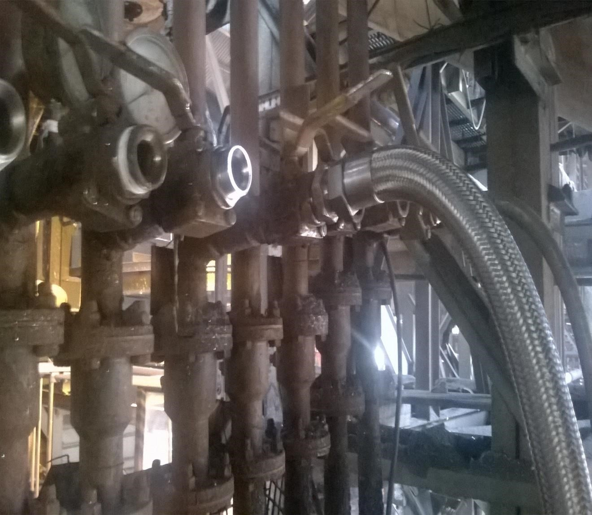
bubble testing water can for doing bubble test.

5.

One 3/4" X 4 mts hose to be connected to 32 nb back flushing valve.

6
. Insert one end of the pipe into the can.

Hose
connected

Outlet
valve

7. Open the 32nb back flushing valve and close the 50nb outlet valve.
8. Water will start coming from the overflow pipe of the can. Water should not overflow from the top and side opening provided for checking CO gas. The flow from the overflow pipe should be in controlled manner by adjusting the inlet valve.
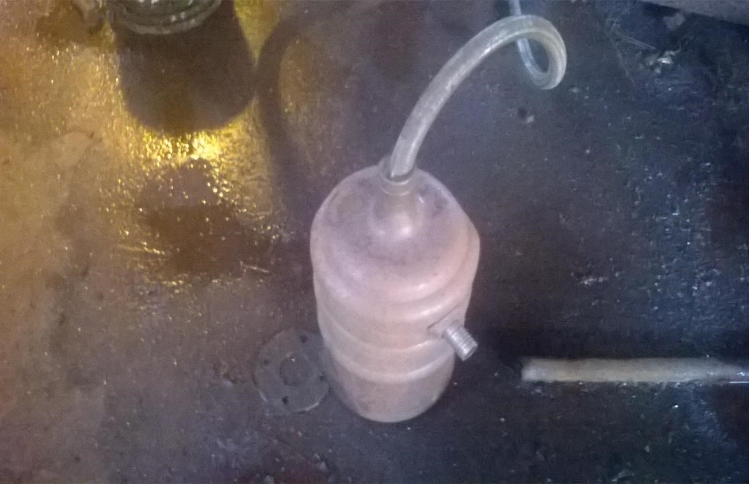
9. Adjust the inlet valve of the cooling plate circuit in such a way that there is no much turbulence inside the can.

Hose
inserted
inside can

Overflow
pipe

10.Wait for around one minute in order to settle the turbulence inside the can .
- Observe for any bubble coming from the hose which is inserted inside the can.
- Place one CO monitor on the opening provided at a higher level compared to the overflow line.
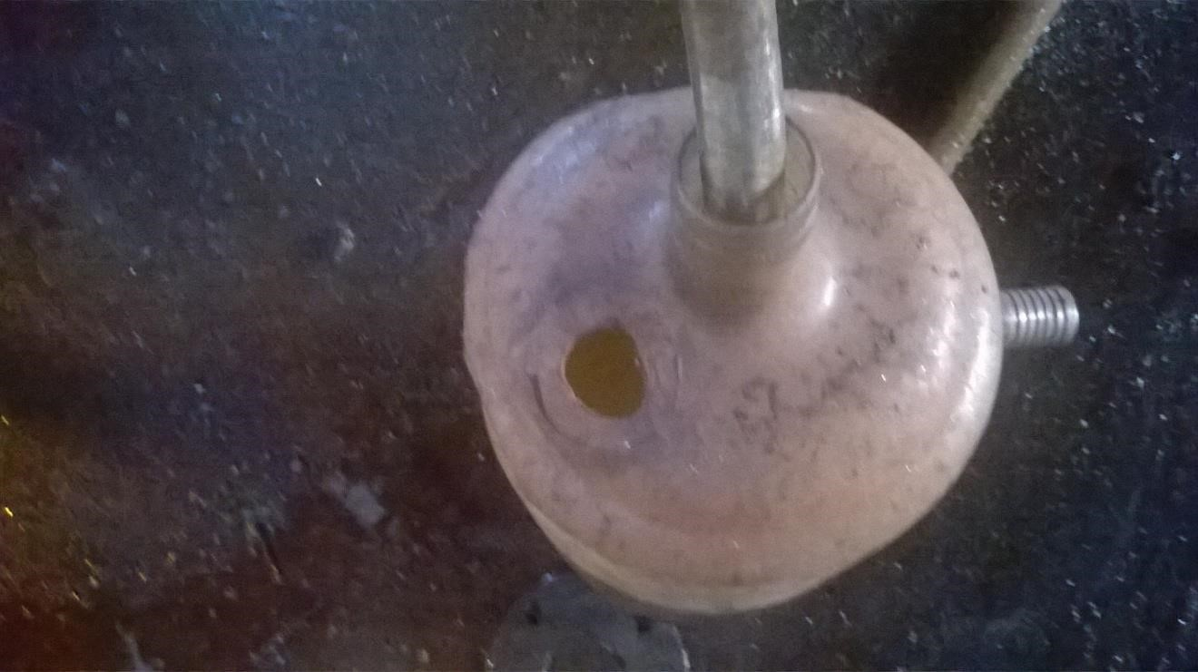

Place CO monitor here
to check presence of
CO gas

13. If CO monitor beeps and bubbles are visible then there is a leakage in that particular circuit.
  - Pressure testing as per the below procedures to be done in order to identify the leakage.
  - The type of procedure to be done for pressure testing to be decided by SS
  - If pressure drop is shown in the procedure done in running furnace the procedure for doing pressure testing in shut down to be conducted prior to plugging any cooling plate.

Procedure for carrying out pressure testing of cooling plate when furnace is in Operation.
  - Team of 2 persons (Production engineer/Mechanical engineer/ Mechanical fitters) should be made to carry out pressure testing of cooling plates. One team shall operate the inlet valve on bustle platform and one team shall operate the outlet valve at the cooling plate outlet trough. They shall carry a walky-talky with them for communication.
  - Both teams should carry 2nos of valve handles, pipe wrench and screw spanner to operate the valve.
  - Both teams to ensure that the communication to operate the valves shall be done with walky talky.
The below circuit is for identification of the leakage in the specific cooling plate for BF1 and BF2. For explanation, cooling plate circuit from 1A1 to 1A4 is considered. As indicated, Inlet valve no. 1, Outlet valve no. 2, Inlet flushing valve No. 3 and Outlet flushing valve no. 4
FIGURE 1
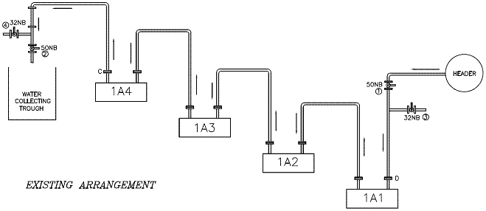
STEP 1:- To identify the cooling plate circuit which is having leakage?
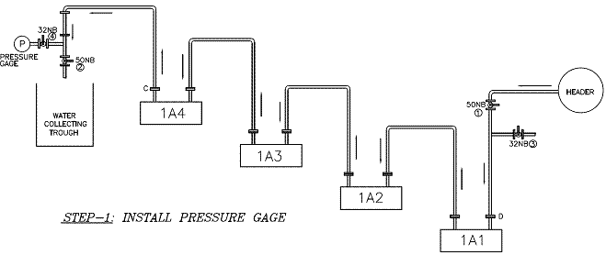
FIGURE 2
    - Pressure gauge (0 to 7 kg/cm2) has been fitted at the outlet flushing valve (4) of the cooling plate circuit.
    - Open the outlet flushing valve no. 4 to see pressure on pressure gauge.
    - Close outlet valve no. 2 and check for pressure which should be equal to pressure of cooling plate header (approx 3.0 – 3.4 kg/cm2).
    - Once the pressure is build in pressure gauge close inlet valve no. 1.
    - Check for pressure on pressure gauge. If for some time pressure remains constant, then it is concluded that there is no leakage in cooling plates. If the pressure reduces, one of the cooling plates in the series has leakage.
    - Re-check above step to ensure to confirm the leakage.
    - In-case after closing inlet and outlet valve pressure in pressure gauge increases more than the header pressure, then immediately open inlet valve since this may be due to water getting converted to steam due to high temperature in that zone. Never allow pressure to exceed more than the header pressure.
    - If there is no pressure drop, than we can conclude that checked series (4 nos) cooling plates are OK. Proceed for checking of next cooling plate circuit.
    - If pressure drops, we have to doubt on leakage in one or more cooling plate in the circuit. Proceed to STEP 2.
STEP 2:- To identify leakage in specific cooling plate circuit (2 at a time):-
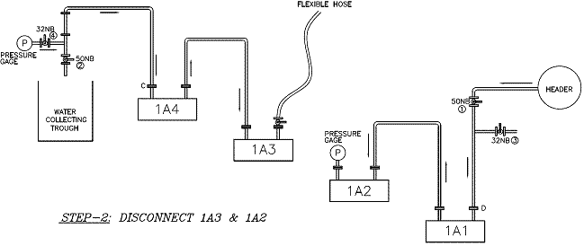
FIGURE 3
  - Connect water hose to the hose connector for back flushing the line at outlet valve no. 4.
  - Reduce the inlet water flow by throttling inlet valve no. 1 of cooling plate header.
  - Be ready for disconnecting the pipe from second cooling plate (1A2) to third cooling plate (1A3).
  - Open back flushing valve no. 4 for back flushing the circuit. Start disconnecting the pipe from second cooling plate (1A2) to third cooling plate (1A3). Once water starts coming either from 1A3 or 1A2, close valve no. 2. Ensure that water is coming out from 1A2 and 1A3 open end.
  - To check leakage in 1A2 and 1A1, install pressure gauge on the outlet of (1A2) and connect flexible hose with valve on the inlet of third cooling plate (1A3).
  - Repeat the following procedure for both the circuits:
  - Open 10% of the inlet valve no. 1
  - Check the pressure on the pressure gauge of (1A2). It should be equal to pressure of cooling plate header (approx 3.0 – 3.4 kg/cm2).
  - If pressure reaches instantaneously, we can conclude that there is no leakage in these 2 cooling plates.
  - To re-confirm, close inlet valve no. 1 fully, if it maintains/increases the pressure, there is no leakage. Then pressure test in 1A4 and 1A3 circuit.
  - If pressure drops, we have to conclude that one or both the cooling plates are having leakage.
  - Once the circuit having leakage is identified, proceed to STEP 3.
STEP 3:- To identify leakage in individual cooling plate:-
FIGURE 4
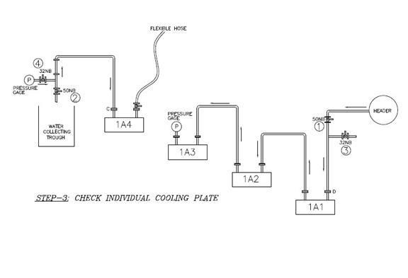
Consider that there is a leakage in the cooling plate circuit 1A3 and 1A4. To understand if there is leakage either in 1A4 or 1A3, follow following steps:
  - Connect 1A3 to 1A2 and open valve no. 2. Refer FIGURE 3.
  - Disconnect the pipe from (1A4) to (1A3). Refer FIGURE 4. Once the water starts coming out open valve no. 4 and close valve no. 2.
  - Install pressure gage on the outlet of third cooling plate (1A3) and connect flexible hose with valve on the inlet of fourth cooling plate (1A4).
  - Open 10% of the inlet valve no. 4 (crack open) for cooling plate (1A4).
  - Close outlet valve no. 2 and check for the pressure. It should be equal to pressure of cooling plate header (approx 3.0 – 3.4 kg/cm2).
  - If pressure reaches instantaneously, we can assume that there is no leakage.
  - To re-confirm, close inlet valve fully, if it maintains/increases the pressure, there is no leakage in forth cooling plate (1A4) and third cooling plate (1A3) is faulty.
  - If pressure drops, we can conclude that there is leakage of cooling plate (1A4)
  - Repeat the exercise for third cooling plate (1A3) to confirm if it is OK or faulty.
STEP 4:- Replace the damaged cooling plate with same size cooling plate or cooling plate of shorter length. This is to be discussed along with Mechanical and Production HOD. Re-connect the circuit as per original arrangement.
OR
STEP 5:- By-pass the damage cooling plate and interconnect hoses to close the water circuit. Fill the cavity with refractory bricks and castable.
STEP 6:
Additional water sprays shall be provided just above and below the damaged cooling plate area. – Resp: Mechanical
Close monitoring shall be done at regular intervals to check the efficiency of water cooling or steaming or for any red spot in that area. – Resp: Production

Procedure for Leakage testing of cooling plates during shut down of the furnace. This procure is made to check whether inlet valve is passing after closing and can be used only when furnace is under shutdown and with due clearance from Shift Superintendent.
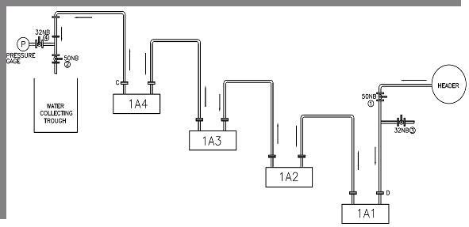
1.Close the inlet valve(no.1) of the cooling plate circuit of which testing has to be done. 2.Closing of inlet valve can be ensured if water stops coming out completely from the outlet valve(No.2).

- Once the water has stopped coming out through valve no.2,connect a hose of 1 1/4" to the socket connected to valve no.4
- Connect the other end of the hose to any nearby outlet valve (No.4) socket and open the valve no.4 and close the valve no.2 of that circuit(Other circuit from which we have taken connection to pressure test circuit in which pressure test is being carried out) 5. Once the valve no.2 of the other circuit is closed water will start coming through the valve no.2 of the circuit which is being pressure tested.
6. Now, close valve no.2 completely of the circuit of which pressure test is being done 7. The pressure will increase in the pressure gauge and will become stationary once it becomes around 3 kg/cm2.
- Close the valve no.4 of the cooling plate series of which pressure test is being done and disconnect the hose.
- If the pressure is not dropped, we can conclude that this cooling plate series does not have leakage.
10. If pressure drop is observed carry out "STEP 2" to identify individual leakages in the circuit. Rest of the steps to be followed as in the case of doing the pressure test in running.
11. The manpower required and precautions to be taken are the same as in the case of doing the pressure test in running.

ACTIVITY-11: Blanking of gas line flanges for isolation

- Objective : - Safe Blanking of gas line flanges for isolation for optimum output and Quality job
- Scope : - Blast furnace & accessories
Ref. : - VL/IMS/PID1/MECH/WI/94, SP 44 & SP 45
- Responsibility : - Engineer In Charge, operator & workmen

PPE –s to be used:

Helmet, Safety shoes, Dust masks, Hand gloves and goggles, seat belt, full body safety harness (working at height)

- The activity should be done with close supervision with min 2 CO monitors.
- Ensure that the water seal is isolated on either side. The gas line should be sealed with minimum 2 water seals on either side of the water seal.
- If sealing of gas line with 2 water seal is not possible, then reduce wind of the furnace which is in operation.
- Take work permit from concerned shift superintendent.
- Take Co-monitor to check the presence of BF gas and monitor till the end of the activity. Job to de only if CO level is below 50 ppm.

- Ensure that steam purging is done & all openings, vent valves are opened.
- Shift the cutting torch, mechanical jack, hydraulic jack, blanking plate with 16 mm ropes put on sides, necessary hardware & spanners at workplace.
- Wear all PPE-s such as safety helmet, goggle, safety shoes & hand gloves.
- Loosen the bolt using the spanner and nut cutter. If not possible to loose the bolt cut the bolts using gas cutting. Follow work procedure SP44 for gas cutting operation.
- Punch-out all bolts after gas cutting.
- Adjust the jack on the both side of the stools of dust catcher flange. Check for the certification of the jacks. Ensure the jacks are not leaking at any joint. Provide packing plates beneath the jack if required.
- Put jack at both sides of stools & lift approximately 50 to 60 mm gap. Put 2nos long bolts 180 deg. apart to arrest any horizontal movement of duct thereby causing misalignment of duct and holes.
- After jacking always stay away from the place for 5 minutes. So that any blocked pockets of CO gas gets released if any.
- Fix 16mm diameter rope on the blank plate & insert the blank such that rope comes on topside of blank.
- Insert all bolts with nut & loosen the jack & remove it.
- Tighten all the bolts uniformly so that there should not be any gap.
- In case of major repairs on gas cleaning system,, Gas cleaning system water pipeline also should be blanked for separating BF1 from BF2 this can be done by placing dummy in the pipeline after taking Gas cleaning system tank level down below the pump center line. Other precaution to be taken is similar to the above.
- Complete activity to be carried out in presence of the Company Engineer and contractor supervisor.
- Follow similar procedure while removing the blank

DO
- Ensure that at the time of jacking, nobody stays near the flange.
- Work in dust catcher after opening top flange of blast furnace and inspection doors in dust catcher.
- Ensure steam is purged thoroughly and relief valves are kept open.
- Monitor Co levels continuously.
- Ensure proper dilution of Co gas to avoid air pollution
- Use two CO monitor while carrying out the activity.

DO NOT

- Put your fingers in between the jacked flanges.

ACTIVITY-12 : Back flushing of cooling plates

- Objective : - Safe back flushing of cooling plate.
- Scope : - Blast Furnace Accessories
- Ref. : - Piping drawing
- Responsibility : - Engineer in charge & workmen on the job

PPE –s to be used:

• Safety shoes, helmet, cotton cloth, goggles and hand gloves. CO detector.

Work No 1 : Back flushing of cooling plate

- Take clearance & work permit from cast house engineer for back flushing
- Connect one end of the 11/4”hose to the spare back flushing valve A provided near the outlet trough of respective cooling plates that needs to be back flushed & the other end should be connected to the 32 NB valve B provided at the outlet of cooling plates.
- Similarly connect one end of the 11/4”hose to the 32 NB D valve provided at the inlet of cooling plate & the other end should be left on the shell or to the nearby drain by securely holding it .
- Now first open back flushing valve A then open 32 NB valve B provided at the outlet of cooling plate line.
- Now partially open 32 NB valve D at the inlet of cooling plate line & close outlet valve C. Finally open 32NB valve D fully & close main inlet valve E
- Keep above mentioned arrangement for 5-10mins. & then revert back to its original condition by following above steps
- Open the main inlet valve E, then open main outlet valve C .
- Finally close valve A, B & D.
- Production engineer & mechanical engineer should be standing both at the outlet trough and the inlet valve area(on bustle platform) to avoid any sudden failures of cooling plates during back flushing.
- The diagram given below can be referred for both BF1 and 2.

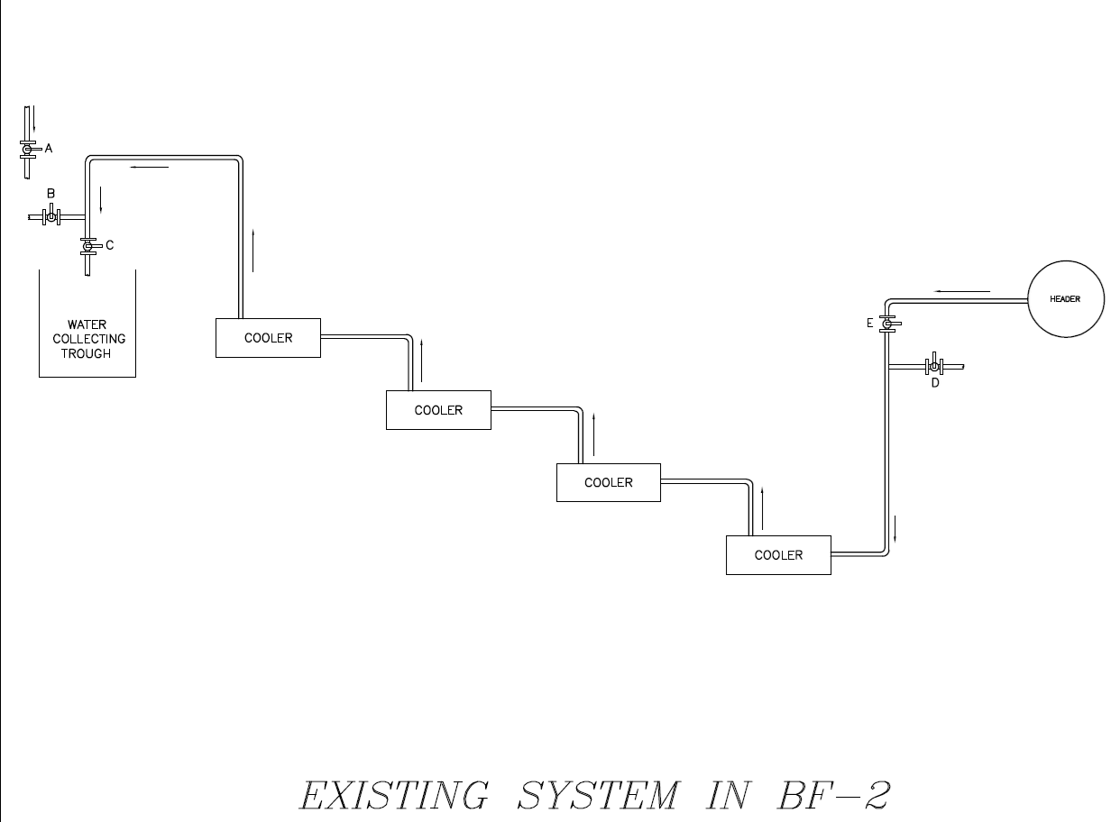

DO’s

- Keep a track of water temperature of cooling plate that needs to be back flushed.
- Ensure that safety goggle is worn by all workmen carrying out this activity.

ACTIVITY -13: PUG MILL MAINTENANCE

- Objective : - Safe maintenance of pug mill for optimum performance
- Scope : - Blast Furnace Accessories
- Ref. : - VL/IMS/PID1/MECH/WI/12, VL/IMS/PID1/MECH/WI/91,
- Responsibility : - Engineer in charge & workmen on job

PPE –s to be used:

• Safety shoes, Helmet, Hand gloves, Cotton cloth and goggle

Work no. 1 : General maintenance of pug mill
Work No.2 : Roller removal of pug mill
Work No.3 : V Belt replacement of Pug mill

Work No.1 General Maintenance of pug mill

- Take the clearance form the production as per work permit procedure
- Take the electrical shutdown..
- Open the inspection door of the gear box. Check for the wear out of the teeth of gears.

- Check for any wear out of the liner plate in the mill. If wear out is observed, change the .liner plate with new one.
- Check the bearings of the main shaft.
- Check for any oil leakages through the gear box.
- Follow material handling procedure VL/IMS/PID1/MECH/WI/12 for handling of rollers, gearbox, and shaft.
- Inspect the structure of the pug mill. If required, strengthen or change the same.
- Follow the housekeeping procedure as per VL/IMS/PID1/MECH/WI/91.
- Clear the electrical shut down as per shutdown procedure.
- Take the trial of the mill
- If the trials found ok, give the clearance to the production.

Work No.2: Roller removal of Pug mill
- Take clearance from production for working on the pug mill.
- Take electrical shut down of the required pug mill.
- After electrical shut down is taken apply local push button of the pug mill for additional safety.
- Clean the pug mill and remove all the clay from the pug mill.
- Cut the locking plate of the shaft and remove the locking arrangement of the roller.
- Using proper leverage remove the roller outside its slot.
- Lift the roller using certified sling and hydra.
- For fixing back the roller follow the opposite sequence for removing the roller.
- After roller is fixed weld locking plate at the shaft end.

Work No.3 : V-belt replacement of Pug mill
- Take shutdown of the required pug mill after taking clearance from production department.
- Mark the existing position of the screw take up using chalk and release the tension of the belt after loosening the screw take up.
- Replace the V belts using new V belts (C 80 for pug mill no.2)
- Tighten the V belts by tightening the screw take up by bringing the motor to the position where the chalk marking is there.
- Clear shut down and take trials.

DOs
- Always take shut down of the pug mill before working on the rollers.
- V-belts to be changed only after releasing load on the belt.

DONTs

- Do not fix the V belts directly without loosening screw take up.
- Do not remove guards while the mill is running or without taking shut down.

ACTIVITY-14: REMOVAL OF STRUCK DRILL BIT FOR DRILL Mc.

- Objective : - Safe & Quality method for removing struck drill bit from drill Mc.
- Scope : - Blast Furnace Accessories
- Ref. : - Drill Mc for BF-01 & 02
- Responsibility : - Engineer In charge (mechanical & production), Production Foreman & Maintenance Fitter on job, production operator

PPE’s to be used:
- Safety Helmet, Safety shoes, hand gloves, Nose Mask, ear plug and goggle

Procedure:

  - Production Cast House in-charge should intimate mechanical shift engineer immediately to remove struck drill bit from drill Mc.
  - Shift fitter should carry following tools from drill bit shed for removal of struck drill bit.
- D-Spanner: 32-36mm
- Pipe wrench: 18 inch.
- Handle mounted Hammer: 1Kg.
  - Drill Mc operating desk key has to be removed and kept by the maintenance fitter
  - Ensure that drill machine is at the extreme end.
  - Ensure drill machine hydraulic pump is kept off before attempting to removal of struck drill bit from drill M/c.
  - Ensure airline valve for flushing is kept closed (LOTO is used) and also air hose is locked with safety chain arrangement along with clamping.
  - Ensure drill M/c scavenging assembly front studs & square head bolts M24x135 are tight or if not should be tightened for effective hammering of machine.
  - Ensure struck drill bit coupler need to be removed manually without any utilization of Drill M/c hydraulic energy (i.e. 2no’s Pipe wrench, D-Spanner, a Handle mounted Hammer & a Cutting set arrangement).
  - Attempt to remove struck drill bit by Pipe Wrench & handle mounted hammer, in case of failed then go for cutting of drill bit (not coupler) in the middle of total drill bit length & dismantle the Air Scavenging assembly unit further replace with new one.
  - After replacing with new scavenging unit give clearance to production in-charge/foreman by handing over the key
  - Trial run of drill Mc operation should be conducted jointly with production.
  - Dismantled Air Scavenging assembly along with struck coupler drill bit should be shifted to drill bit shed for coupler removal.
  - After removal of struck drill bit coupler, Air Scavenging assembly should mounted with drifter assembly which at Mechanical Workshop.

Do:
- Ensure drill machine hydraulic power pack pump is off.
- Operating desk key to be under the custody of company workmen.
- Only production engineer or tap hole operator should operate the drill machine.
- Stay away from drill machine and runner while in operation.

Do not:
  - Don’t try to utilize hydraulic energy for struck drill bit operation.
  - Stand in drill machine swing area when it is in operation.
  - Move inside the swing area of drill machine during operation
  - Keep the burnt or removed drill bit below or by the side of drill machine.

ACTIVITY-15: MAIN LAUNDER AND RUNNER REPAIR.

- Take the work permit from the Production in charge/ Project In-charge. Verbal permission is adequate during relining.
- Cool the runner to ensure complete cooling of hot metal in runner with the permission of shift superintendent. Spraying excess water on hot metal could result in an explosion. Spray water judiciously.
- Dismantle the refractory material of the launder with a ‘bhari’’ or a pneumatic breaker. Refer VL/IMS/PID1/MAINT/WI/22 for pneumatic breaking. Use safety goggles during the breaking operation.
- Fabricate the launder as per the drawing issued. Refer VL/IMS/PID1/MAINT/WI /94 for fabrication and VL/IMS/PID1/MAINT/WI/12 & SP44 for material handling
- Erect the launder as per the approved drawing.
- Obtain permission from concern In-charge before the final welding.
- The launder should be well supported from the bottom. Full welding to be done with launder plates.
- Fill sand between “false launder” and main launder.
- Maintain the slope at the front launder portion as per drawing Once the erection is completed, complete welding. Full welding to be done for entire joining.
- Start the refractory job.
- Permissible Bricks joint thickness is 1to 1.5 mm. Bricks to be cut whoever required to maintained joint thickness. Quality to be used as per approved drawing.
- Wear the safety belt while working near spout. Make a suitable platform from bottom, for better access.
- Care to be taken during cutting plate for skimmer bob hole of main runner, as during skimmer bob preparation castable filling we install a hallow pipe to maintain a hole gap below skimmer for metal & slag separation. During castable filling moisture is trapped inside enclosed hallow section during plate cutting with cutting set steam may get entrapped due to heat & may get out burst to spread all over the cutter face or body.
- Do not work in launder spouts / Y launders with hot water in slag pit / hot metal ladle below the spout.

Hazards identified
- Physical Hazard:
- Pressure, temperature
- Burn injury from metal, runner, and furnace.
- Pressure from hydraulic system, furnace, etc.
- Burn injury due to flame in mud gun mass while gas cutting the nozzle bolts.
- Impact of nozzle due to hydraulic pressure and fire while gas cutting the nozzle bolts.
- Back Pain due to sudden or heavy load like gear boxes, drums & motors
- Temperature of the blow pipe
- Contact with hot coke
- Contact with hot air or hot metal/slag.
- Hand/ body Contact with hot blowpipes or water diverting plates
- Burn injury while handling hot items like wedges, front swivel flange and ball valves of peep hole assembly
- Hot castable spatter of skimmer bob hole cutting during runner repair.
- Mechanical Hazard:
- Fall of material like hammer, tools, slinged items, bolts, blow Pipe wedges
- Fall of person from platform,
- Entanglement
- Impact of moving / slinged items
- Burn injury due to hot metal splashing
- Burn injury due to slip in launder / runner
- Pressure of oil during sudden removal of hose in pressurized condition
- Fall due to slippage of spanners from leverage pipe.
- Trapping between two objects
- Jamming of finger while fixing hose on to the connector
- Slipping / skidding due to poor housekeeping
- Fall from the gap between bustle platform & furnace.
- Impact with supporting angles of header, pipe line etc.
- Fall due to entanglement with slag granulation valve
- Fall of objects such as hammer, barrel, piston, nozzle, etc.
- Fall of person from height.
- Fall due to slippage of spanners from leverage pipe
- Fracture of hand when hands are in between drill bit and carriage and drill machine is operated
- Breakage of cutting wheel
- Falling of peep hole flange, wedge & pins
- Falling of person into the runner while working near blow pipe no1 & 8 due to slippage.
- Hitting of mud gun & drill machine while opening flanges of blow pipe no. 1 & 8
- Cut on hand due to wire rope
- Slip of wheel from height
- Failure of lifting tools & tackles

- Electrical Hazard:
- Electrical shock due to faulty line.
- Electric shock due to improper insulation of welding holder
- Wearing Wet cloth during welding
- Chemical Hazard:
- Gas poisoning, explosion due to gas cutting
- Gas poisoning from furnace and tap hole
- Fire & Fumes.
- Gas poisoning due to improper flaring of flare stack, gas holder etc.
- Fire and explosion due to gas cutting & welding

- Behavioral Hazard:
- Person working under alcohol
- Horseplay.
- Person bypassing work instruction.
- Non usage of PPE s like helmet and dust mask

Amendement Record
Date | Manual Section Ref. & Para | Brief details of Revision | New Rev.

Prepared By:  Area Engineer | Reviewed & Issued By:  Management Representative | Approved By:  Mechanical Head
Signature | Signature: | Signature:
Review Date: 12.12.22 | Review Date: 12.12.22 | Review Date: 12.12.22

